ECE 329
Digital Circuit Design II + Lab.
Fall 2018/2019
LAB # 10
10.12.2018
Objective:
To learn about Complementary Metal Oxide Semiconductor (CMOS) Logic.
- Understanding the CMOS Logic
- Designing fundamental logic gates on Orcad.

- Design the following task on ORCAD by CMOS Logic.
Tasks:
- Design an inverter by using one n-channel and one p-channel CMOS and simulate.
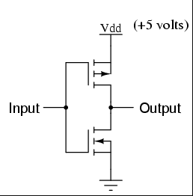
n-channel
p-channel
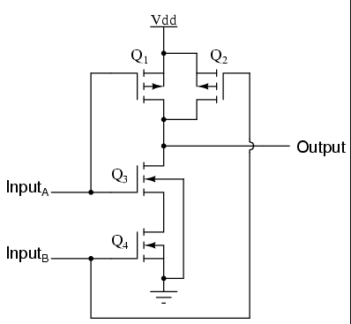
- Design a NAND gate and simulate.

- Design a NOR gate and simulate.
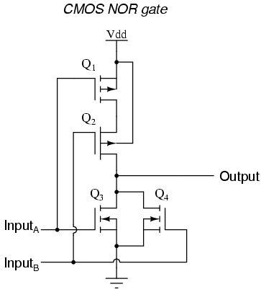

- Extend your NAND gate to AND gate and simulate.
- Extend your NOR gate to OR gate and simulate

CMOS LG designs are taken from https://www.allaboutcircuits.com/textbook/digital/chpt-3/cmos-gate-circuitry/

