ECE 329
Digital Circuit Design II + Lab.
Fall 2018/2019
LAB # 7
19.11.2018
Objective:
To learn about serial adders and 4-bit operations.
- Understanding the Serial Adder Working Principle
- Designing 4-bit adder and subtractor

- Design the circuit of Figure 1 on ORCAD and accomplish the following tasks.

Procedure:
- Arrange two different digstim inputs for shift registers.
- Simulate your design on Orcad.
- Verify your results.
- Explain how this circuit works by your words.
- Design a 4-bit adder and 4-bit subtractor on ORCAD by using the element ADD1.

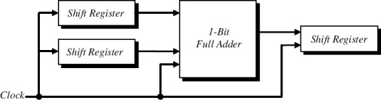

FIGURE -1

