ECE 329
Digital Circuit Design II + Lab.
Fall 2018/2019
LAB # 9
03.12.2018
Objective:
To learn about Transistor Transistor Logic (TTL).
- Understanding the Transistor Transistor Logic
- Designing fundamental logic gates on Orcad.

- Design the following task on ORCAD by TTL.

Tasks:

- Design a Nand gate and simulate.
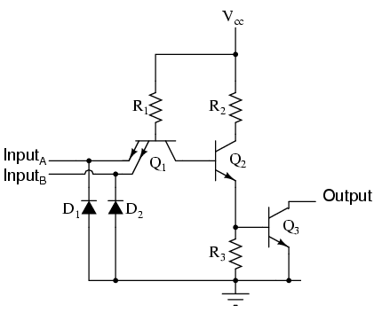
- Design a Nor gate and simulate.
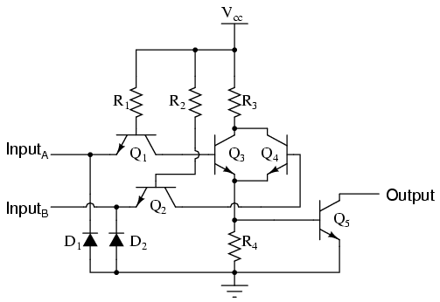

- Extend your Nand gate to And gate and simulate.
- Extend your Nor gate to Or gate and simulate

